To create instructions which tells the reader what to do in a clear and concise way, you might want to:
EYFS | Year 1 & Year 2 | Year 3 & Year 4 | Year 5 & Year 6
- Based on a real experience, discuss and list what is needed to tell someone how to do something and what steps need to be taken e.g. a class cooking activity, cleaning my teeth, How to get to another part of the school to another etc.  - Make a map to show a process getting the steps in the right order  - Use the map to learn and retell instructions with a few simple steps, with appropriate actions emphasising use of language features:  - Time conjunctions/signposts: first second; then, next, after that etc. as for recounts.  - Imperative (bossy) language e.g. Put the flour in the bowl, then add some water, mix them together etc.  - Invent and retell new instructions by changing the map.  (These can be imagined and creative to practice and learn the structures above e.g. How to get to the moon; How to make baby bear happy; How to make soup for a giant etc.) | - Use a clear title starting with ‘How to…’ e.g. How to make a model lighthouse.  - Have clear subtitles: What you need: / What to do:  - Underline your title and subtitles.  - Have a clear list of needed equipment/ingredient  - Use bullet points to organise equipment/ingredients.  - Use numbers or letters to organize steps  - Carefully select bossy (imperative) verbs to clearly state what to do e.g. cut, bake, glue, fold, mix etc. Try to avoid general imperatives: get, put etc,  - Use time conjunctions/signposting to clearly sequence the steps: first, next, after that, then, finally  - Keep your sentences short, clear and concise.  - Sparingly use some controlled adverbs and adjectives to help explain how to carry out a step, e.g. Carefully glue the bottle tops to the red card.  - Use diagrams, arrows, pictures etc. alongside text, where it helps to make instructions clear. | - Have an interesting title to grab reader’s attention  - Consider sparing use of adverbs and adjectives for brevity and precision  - Experiment with varied sentence order and openings for emphasis and effect e.g. Carefully, place them on the board before …,  - Use diagrams etc. alongside text to clarify meaning  - Include introductions to interest or hook the reader e.g. These simple directions will help you to… Have you ever wondered how to…? Have you ever been bored by…Well this game will give you hours of fun…  - And conclusions to wrap up and summarise e.g. Follow these directions carefully and you will never need to…; These simple instructions should enable anyone to…  - Use appropriate punctuation: commas for lists, colons and bullets, for points and sub-points, new lines and paragraphs etc. to frame the sequence for readers.  - Use a range of add-on and drop-in phrases/clauses to advise and warn e.g. Without spilling it, transfer the powder to…; the next player, who should have taken a card already... ; First climb up the beanstalk, taking care not to…,  - Use a range of prepositions appropriately to indicate place, position and time accurately, e.g. in front of, behind, beside, while etc. | - Increase the complexity of topics and steps to include to include:  - explanations e.g.: who the instructions are intended for;  - to introduce technical language;  - to guide readers on how to use the instructions;  - to describe/define outcomes e.g. what counts as winning, what a product should look or taste like, how it should behave; etc.  - Experiment with multiple prior or parallel steps where appropriate, e.g. Before this can be done, the ends should be tied off so that …While the glue is setting, cut the wires to fit round …  - Give your reader options, e.g. at this point you can either (a)…or (b)…; …any player may roll the dice but only the player with…etc.  - Add advice or hints and tips e.g. Before you take the wrapping away…, You may need another pair of hands to help you do this…, although this could be done without drawing the lines,…  - Decide whether it will help to use symbols, diagrams, pictures, flow charts etc. to support the text.  - Vary the tone and formality e.g. to make instructions to sound:  - authoritarian with uncompromising imperatives e.g. Leave the building quietly, Do not leave the area until…,  - or more friendly and reasonable by using modal verbs may, might, should, could, would etc. and phrases like provided that…, so long as… etc.  - speak to a general audience e.g. These regulations are intended for the use of…,  - or to an individual e.g. To get the best results, take a few minutes t …  - When you have finished, check carefully to ensure your instructions are:  - make sense and are free of ambiguity and contradiction,  - effectively sequenced to achieve their objective,  - can be understood by others.

Typical ingredients of instructions text:
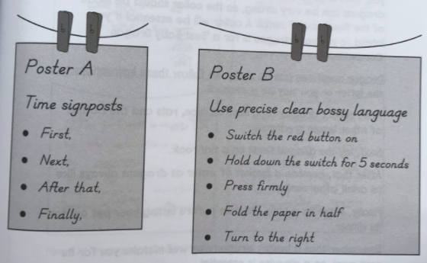
Audience | - Someone who needs to know how to do something
Purpose | - To inform the reader about how to accomplish something in as clear a way as possible.
Typical Structure | - Opening that explains what the instructions are for and why they might be necessary.  - List of what is needed in order to use.  - List of steps to be taken in chronological order.  - Often uses diagrams  - Ending – that adds in any extra points, reminders, warnings or encouragement to the reader.
Typical Language Features | - Temporal signposts to organize the steps taken, e.g. ‘first’, ‘next’, ‘after that’, ‘then’, ‘so’, ‘finally’.  - Steps to be taken: organized by numbers, letters of the alphabet or bullet points.  - Fairly formal as the reader may be unknown.  - Use of short sentences to make the writing very clear and easy to follow.  - Use of ‘bossy’ words (imperatives), e.g. ‘turn’, ‘push’, ‘click’, ‘stir’, etc.  - Subject specific and technical vocabulary.  - Commas used when writing a list of ingredients or tools. Possible use of colon before a list, e.g. What you need: a spade, bucket and trowel.
Examples | - How to make a pizza.  - How to invade a walled city.  - How to keep ourselves warm.  - How to work the computer.  - How to keep an alien happy.

