To create explanation writing which explains actions, ideas or processes to the reader, you might want to:
EYFS | Year 1 & Year 2 | Year 3 & Year 4 | Year 5 & Year 6
- Listen to and discuss short simple explanations | - Use a three part structure which should comprise of:  - A title which sets up expectations for the reader e.g. Why we must look after our bees…,  - An opening that introduces reader to the topic and signals the purpose of the text e.g. Bees are winged insects which play an important role in our ecosystem.  - An ordered list of reasons or events leading up to the outcome signalled in the title e.g. Firstly, Bees are important because they can make honey. They also help trees and plants to grow …  - A conclusion which follows from the reasons listed in section 2 and links back to the title e.g. So without bees, we would have no fruit. Now you know why they are so important.  - Where appropriate, use generalising words: e.g. most, many, some, few  - Use conjunctions for:  - time and sequence: then, before, when etc. first second etc. to sequence information leading towards the conclusion;  - cause and effect to link reasons/motives and conclusions: so…, so that…, because…, in order to… , that’s why…, etc.  - Use well-chosen adjectives to denote size, colour, behaviour etc.  - Use prepositions to show position and direction: behind, above, towards etc.  - Write in the present tense and usually 3rd person to give text an impersonal and objective voice. | - Extend use of three-part text structure, boxing up the text:  - general statement to introduce the topic, e.g. in the autumn some birds migrate  - a series of logical steps explaining how or why something occurs, e.g. because the days get shorter and there is less light…,  - steps continue until the explanation is complete.  - End with a summary statement or memorable piece of information: As a result, Dinosaurs quickly became extinct along with about 50% of other animal species.  - Interest the reader e.g. with:  - a title that captures the text The discovery of bubble gum; Why are dragons extinct?  - an exclamation: Beware, foxes can bite!  - questions, Did you know that…?  - tempting turns of phrase: strange as it may seem…, not many people know that…, Interestingly…  - add extra, interesting bits of information e.g. the first balloons were made from animal intestines.  - Collect and use a range of conjunctions and generalisers to link sentences and add interest for readers:  - For cause and effect e.g. this means that…, as a result…, owing to…, in order to, leading to…, where…, when…, therefore…, consequently…,  - to add information: e.g. as well as…, furthermore…, additionally…, moreover…, Not only…,  - to compare: like the…, similarly.., as with…, equally…, in contrast to.., etc.  - for emphasis: most of all…, most importantly…, In fact…, without doubt.., etc.  - to generalise e.g. all…, many…, the majority…, typically…, Like most…, always…, often…, sometimes.., usually…  - to conclude: finally.., so…, thus…, in conclusion…, to sum up…, which explains why…, etc.  - Use technical language, explaining what it means where necessary.  - Use descriptive language to illustrate key points and help the reader build a picture of what is being explained  - Use mostly present tense, 3rd person in formal style for an unknown audience. Use correct punctuation for sentences, clauses, questions, exclamations. | - Help readers to understand explanations through:  - Introductions that link to their experiences e.g. No doubt you will have seen a suspension bridge, and it is almost as likely that you have travelled over one.  - giving examples: other mammals, such as flying squirrels and gliding possums, can only glide for short distances.  - Inventing similes to illustrate points e.g. a tree’s bark is like our skin…, the cables of a suspension bridge are stretched under tension like a spring..,  - possible use of diagrams, charts, illustrations or models.  - Use expanding the range of conjunctions and generalisers, particularly those showing:  - cause and effect  - use of provisional statements with words and phrases like usually…, seem to be…, tend to…,  - opinions as well as facts e.g. Some people still believe that… It used to be thought that…  - technical vocabulary to add precision e.g. spine, compression, glucose  - references to sources of evidence to add authority e.g. Most people now believe…, However, last year, a new variety was discovered…  - Vary sentence structure, length and type e.g.  - complex sentences to combine information effectively: The Outer bark keeps a tree from losing too much water, which could happen easily in a plant so large…;  - sentences with lists of three: Pulleys are used on boats to hoist sails, in garages to lift engines and in cranes for shifting heavy weights;  - active and passive voices: suspension bridges have cables strung between tall towers from which a deck is hung (or suspended);  - conditional and hypothetical (if…then) sentences e.g.: If trees lose (were to lose) their bark, they would die because…; If Fleming hadn’t accidentally noticed the mould, we might not have penicillin today.
Typical ingredients of instructions text:
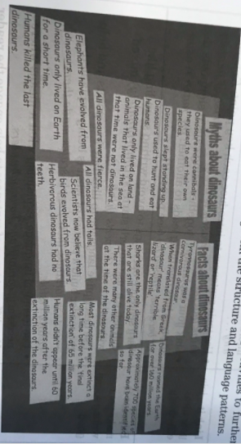
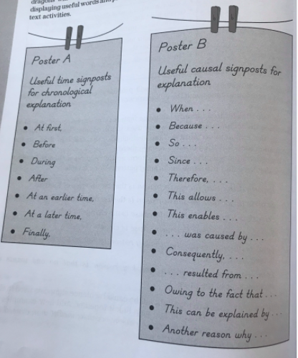
Audience | - Someone who wants to understand a process or event.
Purpose | - To help someone understand a process or why something is, or has happened.
Typical Structure | - Series of logical – often chronological – explanatory steps  - Paragraphs usually beginning with a topic sentence.  - Often illustrated by diagrams to aid understanding.
Typical Language Features | - Formal language  - Present tense  - Causal sentence signposts to link explanation  - Generalisation  - Tentative language to refer to unproven theories.  - Detail to help understand points – often in form of information.  - Technical vocabulary
Examples | - How does a bicycle pump work?  - Why does it get colder when you go up a mountain?  - How did the Egyptians build the pyramids?

