To create discussion writing which helps the reader to think and reflect, you might want to:
Year 1 & Year 2 | Year 3 & Year 4 | Year 5 & Year 6
- Learn and retell prepared text on the issue that you have been discussing with  - a title: Should we keep a animals in the classroom?  - an opening sentence to introduce the issue e.g. We have been discussing whether we should…  - list points in favour e.g. Some of us think we should keep animals in the classroom, Our reasons are:…,  - use numerical conjunctions: firstly, secondly etc.  - then change viewpoint e.g. On the other hand…, and list points against,  - An ending e.g. In conclusion/so, we think that…etc.  - Use complete simple or compound sentences with correct punctuation.  - Write mostly in the present tense 1st person (I or We)  - Focus on a few essential conjunctions to join ideas and structure the argument:  - whether (or not)…, to set out alternatives. But…, although…, on the other hand … etc. to mark change of viewpoint;  - if…then…, to show consequences e.g. If we keep animals in the classroom, someone will have to look after them at the weekend…; | - Develop the framework from Y1/2, boxing the text up, to create connected paragraphs in place of simple sentences and lists:  - opening paragraph to interest the reader in the topic e.g. Since the arrival of the Daleks, there has been much discussion about whether…  - a series of points in favour in a connected paragraph,  - a series of points against in a connected paragraph  - a reasoned conclusion which can be justified by the arguments.  - Use complex sentences to combine information, create emphasis and make the text more interesting for the reader:  - relative clauses e.g. Daleks, who are fearless and hard-working, are also…,  - subordinate clauses: While many people think this is a good thing, others believe…, First they point to the fact that, when Daleks have previously visited, they always…, etc.,  - Use generalised language to depersonalise and objectify the writing:  - generalisers: some, most, everyone,  - category nouns e.g. people, animals, food, vehicles, vegetables.  - Use a variety of conjunctions and connecting phrases to guide the reader through the argument:  - to set out alternatives and set the scene e.g. to decide …whether or not/ if we should/ where the/ either…or etc…,  - to add on and sequence ideas e.g. The first reason…, also.., furthermore…, moreover…,  - to introduce a different viewpoint e.g. However…, On the other hand…, many people also believe that…  - to conclude e.g. In conclusion…, Having considered the arguments…, Looking at this from both sides… Use correct punctuation for sentences, clauses, questions, exclamations. | - When assembling arguments:  - try to support views with reasons or evidence,  - or make clear that these are your opinions e.g. I think.., in my opinion…,  - or try to persuade – see below.  - Write openings to introduce the reader and explain why you are discussing an issue e.g. Since last summer, people have been arguing about whether or not to build a new supermarket next door to our school. We think everyone should be clear about the reasons before a decision is made.  - Give examples which move from the general to the specific: Most shoppers would agree that … One lady who has shopped in the town for many years told us…  - Use indirect, reported speech e.g. It has been said that…, the local policeman told us that…  - Vary sentence structure, length and type e.g.  - complex sentences to combine and compress information: Although the new store will be easier to drive to, it will cause traffic congestion around the school and increase the likelihood of accidents to children.  - Short sentences for effect e.g. No-one wants this.  - Sentence openers: interestingly…, from our point of view…, Indeed there could even be…,  - Passive voice to sound more formal: It could be said that…,  - Conditional and hypothetical (if…then) sentences using the subjunctive ‘were’ If that’s the best they can offer…, If it were to be approved…,  - Use persuasive devices to press points - see toolkit guidance for persuasive texts Address readers directly from time to time to hold attention and draw them in to the arguments:  - inviting them to speculate: You may be wondering why…,  - asking questions e.g. How would you like to meet one of these creatures on your way home…  - using exclamations e.g. …and they smell horrible!  - Extend the range of conjunctions given in Y3/4 to link sentences and paragraphs interestingly, coherently and effectively. Including: addition: also, furthermore, moreover, etc.  - change of direction: on the other hand, however, although, unfortunately, despite etc.  - cause and effect: so that…,, owing to…,, due to…, etc.  - uncertainty: perhaps, it is possible that…, another possible reason… etc.  - comparison: equally, similarly, just as…, in contrast, whereas etc.  - Emphasis: most/least of all…, importantly etc.  - Make views sound more reasonable through use of modal verbs e.g. might/may/could be, and words and phrases that leave room for alternative views or contrary facts e.g. often/usually/commonly/mostly/tend to/are likely to…  - Use a variety of phrases for drawing conclusions e.g. In conclusion…, to sum up…, Having considered…, In the light of…, given these arguments …, On the whole…, By and large…, In the circumstances…, All things considered…

Typical ingredients of instructions text:
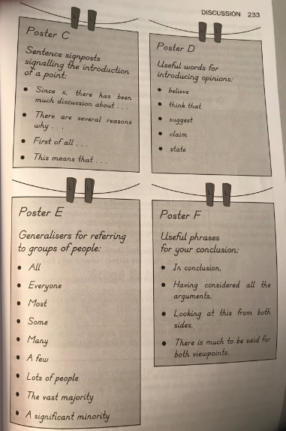
Audience | - Someone interested or involved in the topic under discussion
Purpose | - To present a reasoned and balanced view of an issue.
Typical Structure | - Opening paragraph that introduces the reader to the issue.  - Followed by a series of paragraphs in a logical order:  - Either beginning with all the arguments for, followed by all the arguments against;  - Or a series of contrasting points ending with a reasoned conclusion. Paragraphs usually begin with a topic sentence.
Typical Language Features | - Sentence signposts to guide the reader through the argument that help to:  - Add on and order ideas and views, e.g. The first reason, also, furthermore, moreover…  - Introduce other viewpoints, e.g. However, on the other hand, many people believe that, it might be thought that…  - Conclude, e.g. in conclusion, having considered all the arguments, looking at this from both sides…
Examples | - Should healthy eating be compulsory?  - Should children be allowed to choose where to sit?  - Should mobile phones be allowed in school?  - How can we improve the playground?  - Should all plastics be banned?
